Assignment 1 OUTPUTS

OUTPUT OF QUES1:

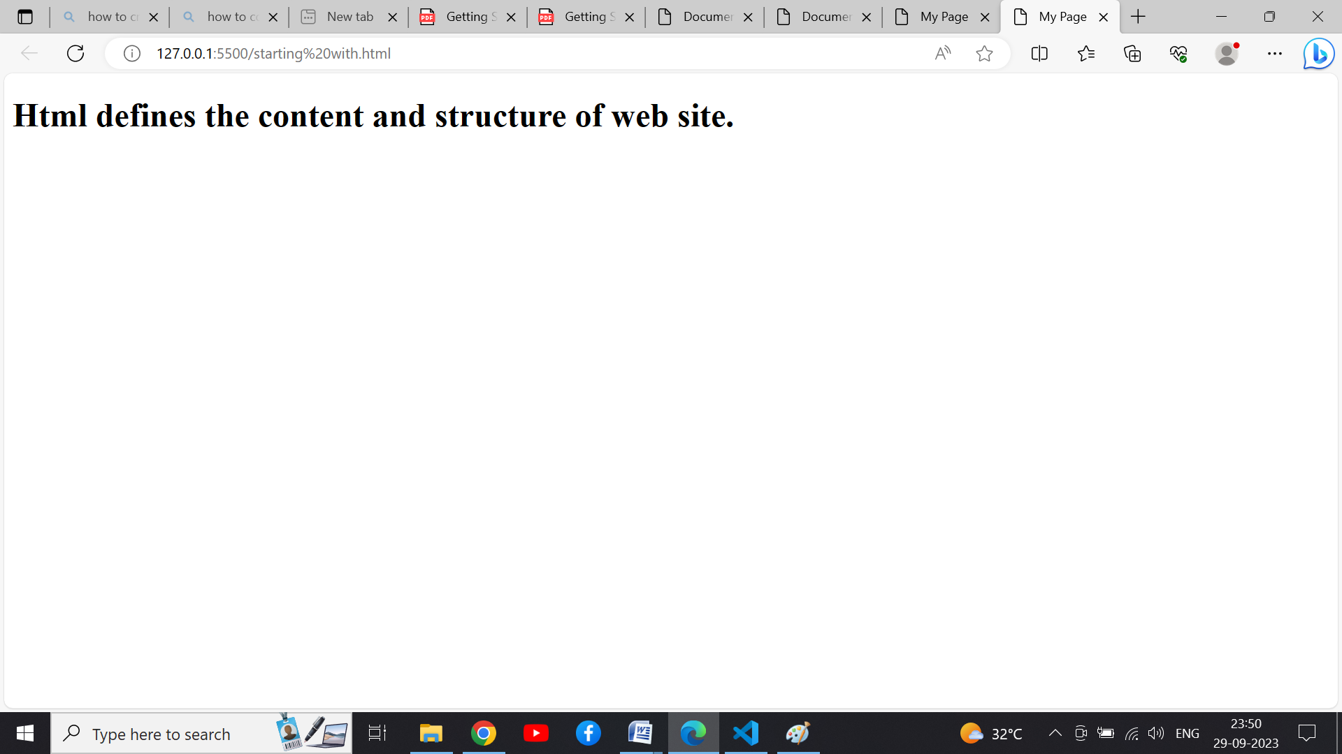

OUTPUT OF QUES 3:

